**Exercise: Create a Private GitHub Repo and Share It with the Instructor**

Alan L. Dennis

University of the Cumberlands

**Exercise: Create a Private GitHub Repo and Share It with the Instructor**

It is common to use a source code repository when doing software development related to artificial intelligence. This document guides you through creating a GitHub repository and sharing it with the instructor. First, general instructions are provided, followed by high-level steps to complete. Lastly, a conclusion will be presented, recapping the information covered.

# General Instructions

After having reviewed the lecture, use this document to provision a GitHub account (if you do not already have one), create a repository, initialize it, and share it with the instructor. Ensure that you document your experience in a short report in APA format. The report should contain at least **two to three pages** of content and a title and references page using APA format. Document any challenges you met and mitigation strategies you utilized. Feel free to include a narrative (in first person) of your previous experiences with source code repositories.

# GitHub Account

GitHub is an online source code repository (commonly termed repo) hosting service. For this course, we will use a repo to house and submit assignments. If you do not have a GitHub account, navigate to GitHub.com and sign up. You will be presented with a simple page, asking for your email address, as shown in Figure 1.

Figure 1: GitHub Homepage

You may use your university email address or a personal address. After entering your email address, you will see a text-like interface. It starts by confirming the email address you previously entered, as shown in Figure 2.

Figure 2: Email confirmation

Assuming the email address is correct, click the **Continue** button. Next, you will be prompted for a password. As of this writing, it must be 15 characters long, or eight if it includes a number and a lowercase letter. After clicking **Continue** by the password field, you will be prompted for a username. This is distinct from your email address. You will receive feedback regarding the availability of the username as you type it, as shown in Figure 3.

Figure 3: Username selection

Next, you will be asked if you wish to receive product updates. After making your selection, you may be asked to solve a puzzle to ensure you are human. Once you have proven that you are human, you can click the **Create Account** button at the bottom of the form.

GitHub will send you an email containing a code. This is to ensure the email address is valid, and that you are in control of it. After you supply the code, you will be asked questions regarding the size of the team, and if you are a student or teacher, as shown in Figure 4.

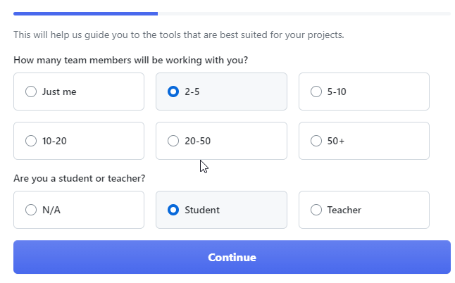

Figure 4: Team size

Since you may use this account for a group project, select 2-5, and that you are a student. Once you have made the choice, click the Continue button. Next, you will be asked about the workload you plan to perform with the repo. Click the button without making a selection. Next, you will have the option to select the free plan. Congratulations, you have created a GitHub account. Now you can create a repository.

# Creating a Repository

A repository is a collection of files. In this case, we will use a repo to house the project files during this course. There are several ways to create repositories. You could create a new repository simply by supplying a name, as shown in Figure 5. For this course, ensure all repositories are private

Figure 5: Create a Repository

Now that you have a repository, you need to initialize it for use. If you are not familiar with git, you should review the documentation (GitHub, 2023). There are many ways to interact with GitHub, but the important thing is to create a file in the repo and then share the repo with the instructor.

Once you have a repository, it is common to create a README file in that repo. Again, there are many ways to do this, but one way is to use the web interface and click the Add a README button. You will need to commit the file to a branch. For this course, it is acceptable to use the main branch.

# Share Repository with Instructor

You are now ready to share your repository with your instructor. Ensure you review the instructor’s GitHub account, which should be supplied in an announcement. If it is not, contact your instructor. The steps to share a repo are well documented (GitHub, n.d.). Navigate to the main page of the repository you wish to share, and select the setting (gear icon), as shown in Figure 6.

Figure 6: Repository Settings

Next, click the Add People button in the Manage access area. You can then search for the person you wish to add. Once you have found your instructor, click the Select a collaborator above button, as shown in Figure 7.

Figure 7: Select a collaborator

After you select the collaborator, the text should change color, and the button text should change to Add <instructor username> to this repository, as shown in Figure 8.

Figure 8: Add collaborator

You will then see the newly added collaborator in the Manage access section. The status of the invitation will change when your instructor accepts it. Ensure that you also follow your instructor.

When you submit assignments during the course of the class, ensure you include your account and the repository name. Also, if you create a different repository for each assignment, ensure you repeat the steps of inviting your instructor as a collaborator, so that they can grade your submission.

# Conclusion

We have discussed the process to create a GitHub account and create a repository. We discussed the process of sharing a repository with your instructor and provided guidance for submitting assignments during this course. Once you have completed these steps, capturing screen shots along the way, you will be equipped to create and submit the short report associated with this assignment. Completing only the creation of the repository and sharing it (without creating the short report) will result in a poor grade.

# References

GitHub, I. (2023). *Getting started with Git*. <https://docs.github.com/en/get-started/getting-started-with-git>

GitHub, I. (n.d.). *Inviting collaborators to a personal repository*. <https://docs.github.com/en/account-and-profile/setting-up-and-managing-your-personal-account-on-github/managing-access-to-your-personal-repositories/inviting-collaborators-to-a-personal-repository>